Knowledge Base

Joystick Troubleshooting

What this document covers

Hints on how to resolve issues that may occur with the FrSky Taranis X9 Lite S joystick used in the Quanser Autonomous Vehicle Research Studio (AVRS).

* Errors when running the Simulink/QUARC models
* Communication issues between the joystick and the PC.

Troubleshooting

Follow the steps below to ensure that FrSky Taranis X9 Lite S joystick, shown in Figure 1, is being detected by your computer, is communicating to the dongle, and confirm using that it is working using the Joystick Visualization Demo.

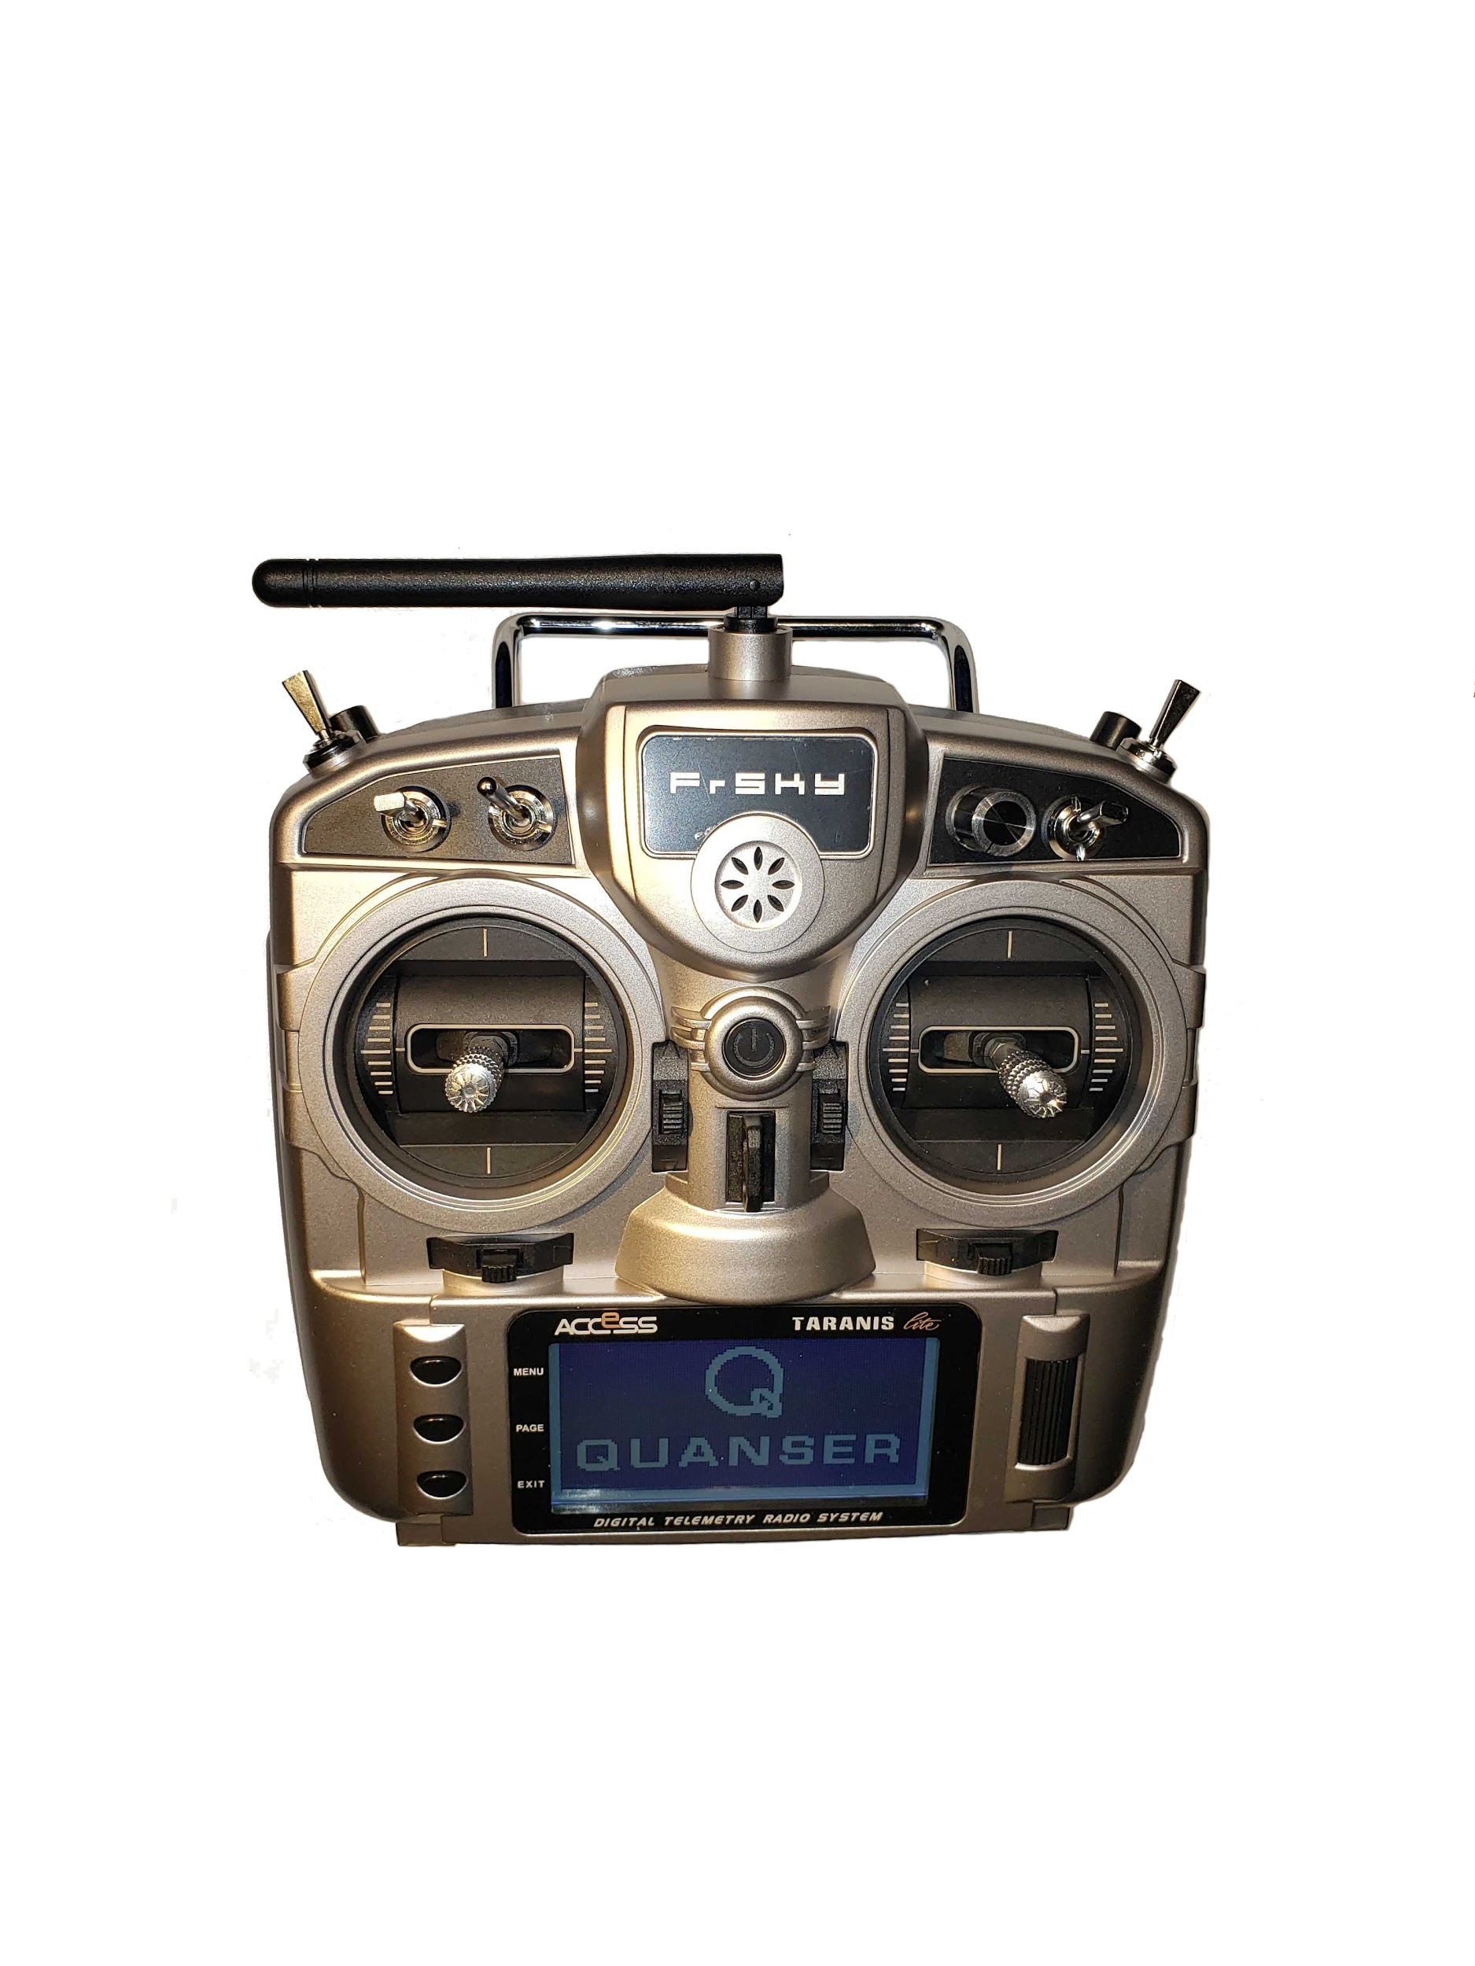

Figure 1: FrSky Taranis X9 Lite S joystick

Make sure Joystick is Setup

Make you have first gone through all the steps outlined in the Joystick Setup section in the Research Studio Setup Guide. This shows how to bind your joystick to the USB dongle and perform the Joystick Visualization Demo test.

Reconnect Joystick USB Dongle

Disconnect and reconnect the USB dongle, shown in Figure 2, into the PC. If the USB dongle is connected for long periods of time, then the joystick may stop receiving data.

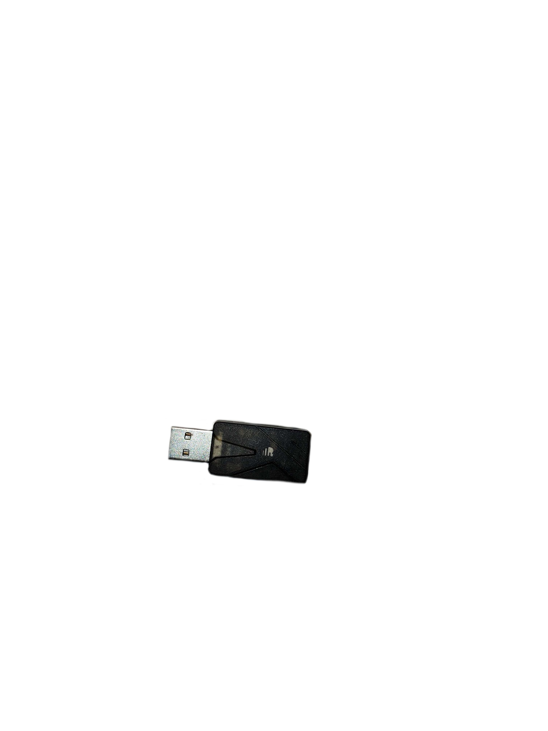

Figure 2: FrSky USB dongle

Check Windows Device Manager

Confirm that *FrkSy Simulator* controller shows up under Windows devices. This can be in different location depending on your version of Windows.

Figure 3: FrSky Simultor in Windows Devices

Test Joystick Communication to USB Dongle

Right-click on the *FrkSy Simulator* device and go to *Properties*.

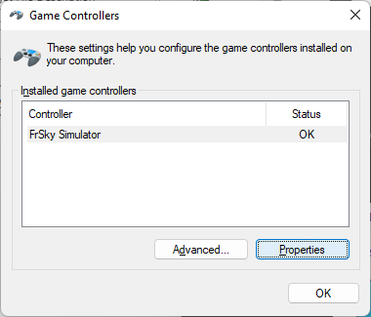

Figure 4: Click on Joystick Properties

The FrSky Simulator properties Windows displays the status of the different buttons, toggles and sticks of the joystick.

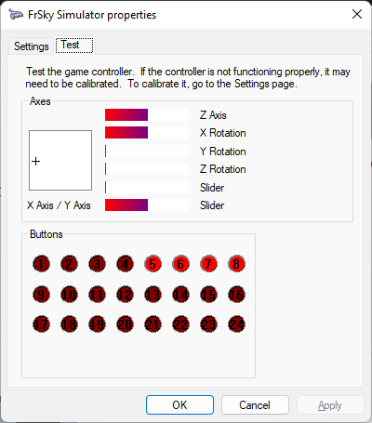

Figure 5: Test if PC gets data from the joystick

Move the joystick handles to see if it responds. This tests the communication between the joystick and the PC through Windows.

Test in QUARC using the Joystick Visualization Demo

Go through *Checkpoint #5: Joystick Visualization Demo* in the Research Studio Setup Guide.

To run the model in QUARC, make sure you click on the **Monitor & Tune** buttonin the *Hardware* tab, as shown in Figure 6.

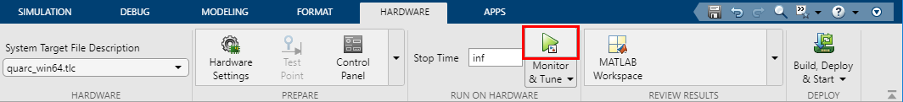

Figure 6: Click on the Monitor & Tune button when using the Joystick Visualization Demo

Do not click on the *Build* button under the *Build, Deploy, & Start* button or you may get a “Simulink Coder Error” shown in Figure 7.



Figure 7: Simulink Coder Error when running Joystick Visualization Demo

QDrone Visualization Not Moving

If the QDrone in the visualization is not moving, make sure both the *Arm* and the *Takeoff* toggles have been activated.

If the QDrone in the visualization is still not moving, confirm that the status bar in the Quanser 3D Viewer displays *Receiving data stream*, as shown below, and not *Connecting*.

Should show “Receiving data stream”, not “Connecting”.

Figure 8: QDrone Visualization

If *Connecting* is shown then follow these steps:

1. Stop the *Joystick_Visualization_FrSky* Simulink model.
2. Double click on **Visualization-1** block in the *Simple Drone Visualization* subsystem

Figure 9: *Simple Drone Visualization* subsystem in Joystick_Visualization_FrSky Simulink model

1. Under the Communications tab, go to the “…” button in the *URI upon which to listen for client (viewer) connections* input.

Figure 10: Open the Visualization Initialize configuration panel.

1. Under the *Options* menu, go to “local” and set is to “No”, as shown in Figure 11.
2. Click on OK.

Figure 11: Set the "local" option to No.

1. Run the Joystick_Visualization_FrSky Simulink model in QUARC.

© 2023 Quanser Inc., All rights reserved.

Quanser Inc.

119 Spy Court

Markham, Ontario

L3R 5H6

Canada

info@quanser.com

Phone: 19059403575

Fax: 19059403576

Printed in Markham, Ontario.

For more information on the solutions Quanser Inc. offers, please visit the web site at: <http://www.quanser.com>

This document and the software described in it are provided subject to a license agreement. Neither the software nor this document may be used or copied except as specified under the terms of that license agreement. Quanser Inc. grants the following rights: a) The right to reproduce the work, to incorporate the work into one or more collections, and to reproduce the work as incorporated in the collections, b) to create and reproduce adaptations provided reasonable steps are taken to clearly identify the changes that were made to the original work, c) to distribute and publicly perform the work including as incorporated in collections, and d) to distribute and publicly perform adaptations. The above rights may be exercised in all media and formats whether now known or hereafter devised. These rights are granted subject to and limited by the following restrictions: a) You may not exercise any of the rights granted to You in above in any manner that is primarily intended for or directed toward commercial advantage or private monetary compensation, and b) You must keep intact all copyright notices for the Work and provide the name Quanser Inc. for attribution. These restrictions may not be waved without express prior written permission of Quanser Inc.